1. Perform automated api testing using Jmeter. Run 50 parallel api request for each of 2 apis of your choice(or 2 api can be api to get product by category and api called to view a product detail) used in above website.

Tree structure:

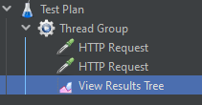

Thread Group:

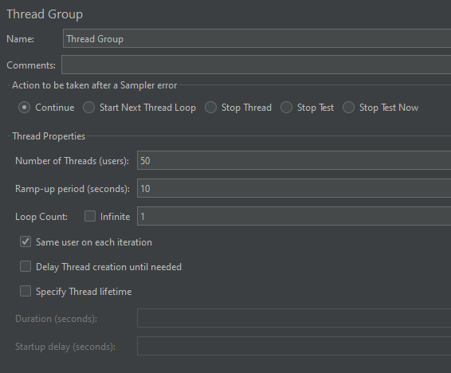

HTTP Request first for entries

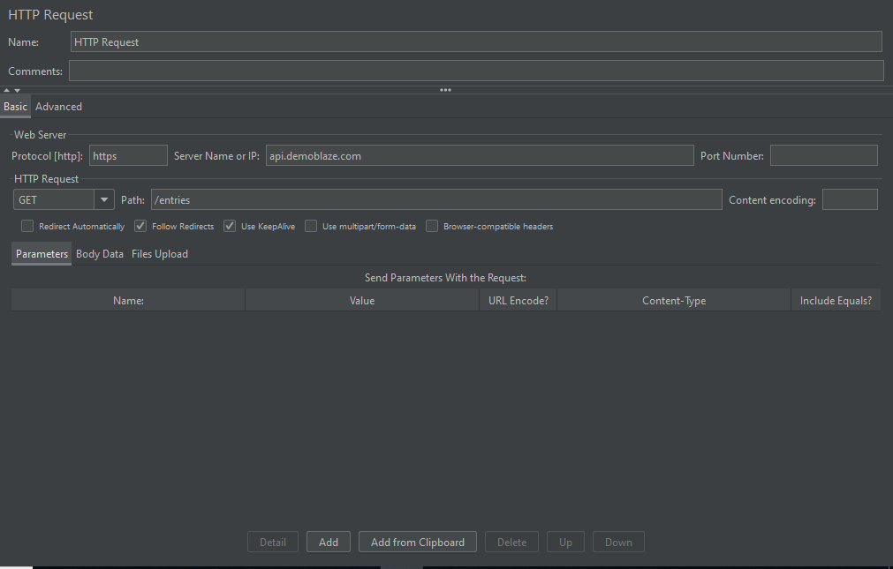

HTTP Request second for view

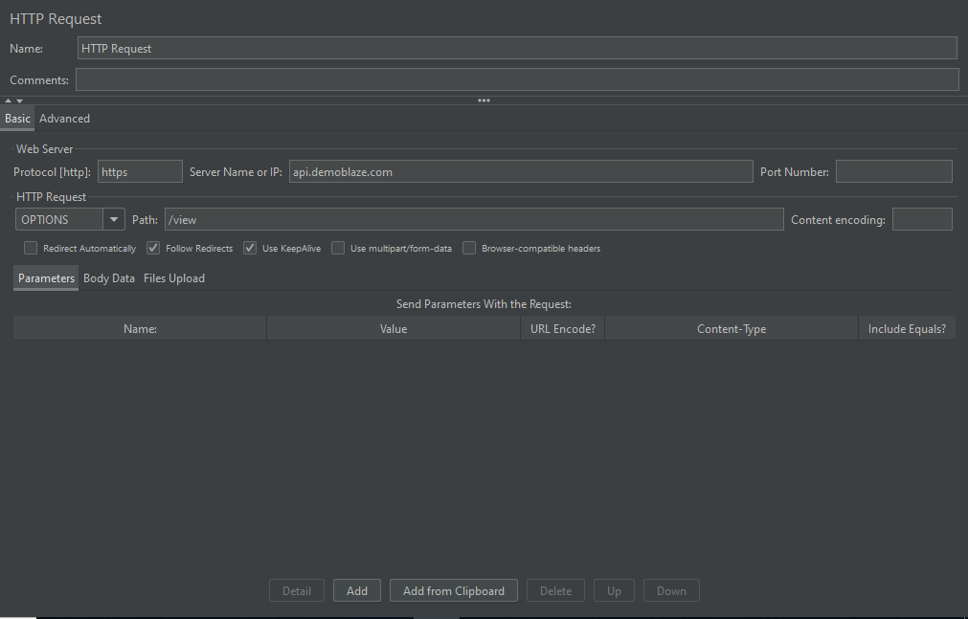

View Result Tree:

